Responding to the Self-Study Standards in ACOTE Online

Log onto the ACOTE eAccreditation Portal (https://acote.aota.org) using a browser such as Firefox or Chrome. Click on the “SELF STUDY” or “INT RPT” tab (depending on the report you are completing), then click on the Standard you wish to respond to (e.g. 2018 Standard A.1.1.):

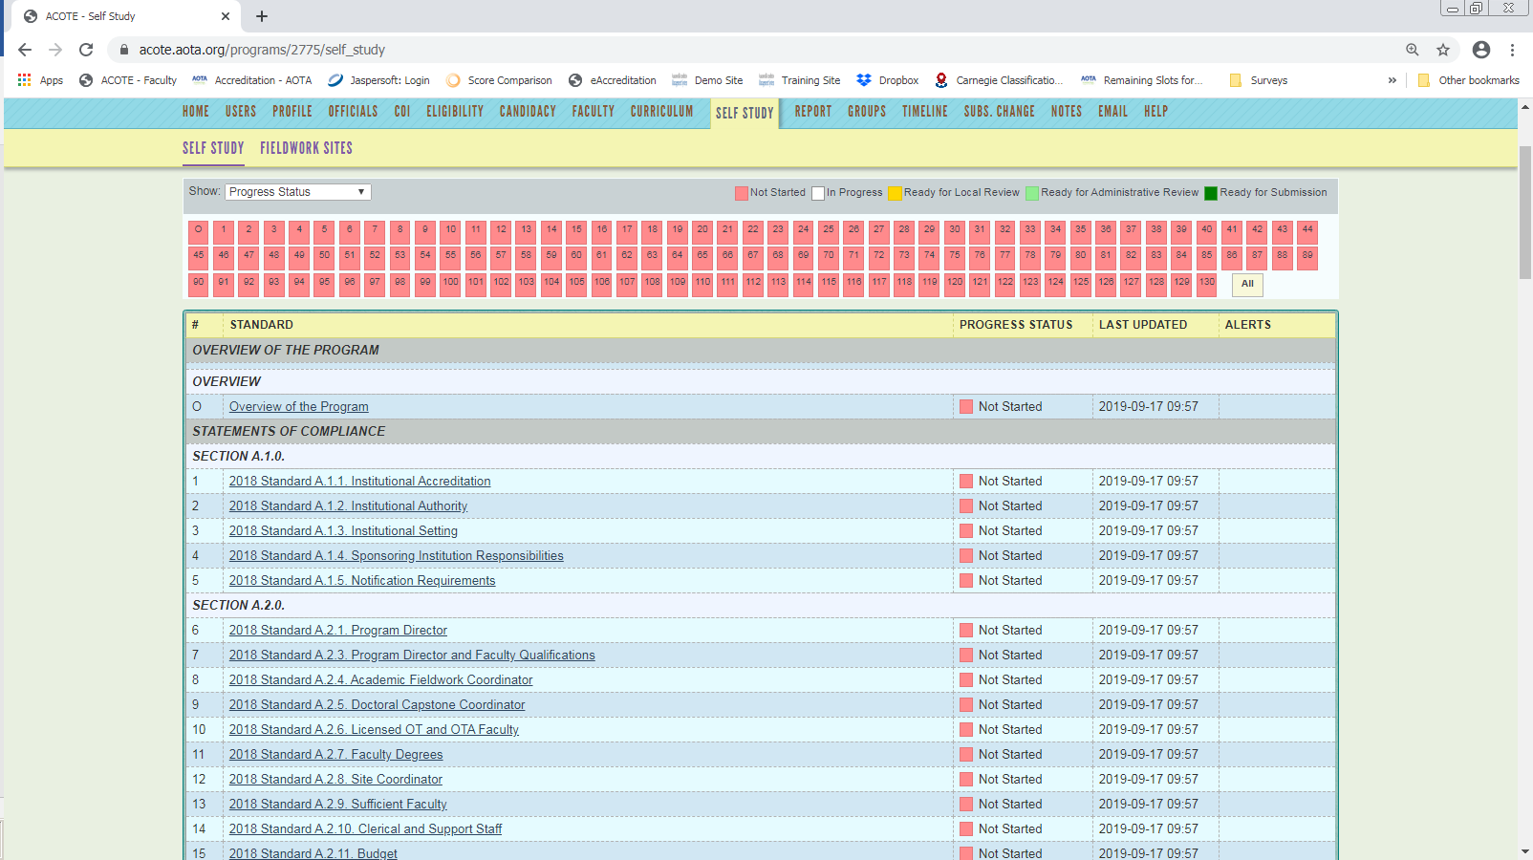

Under that Standard, enter your narrative response in the “Compliance Statement” box.
- If you are cutting and pasting from a Word document, it is recommended that you use the “Paste from Word” icon to insert text (see blue arrow below).
- Make sure to hit “Save Response” to save your response.

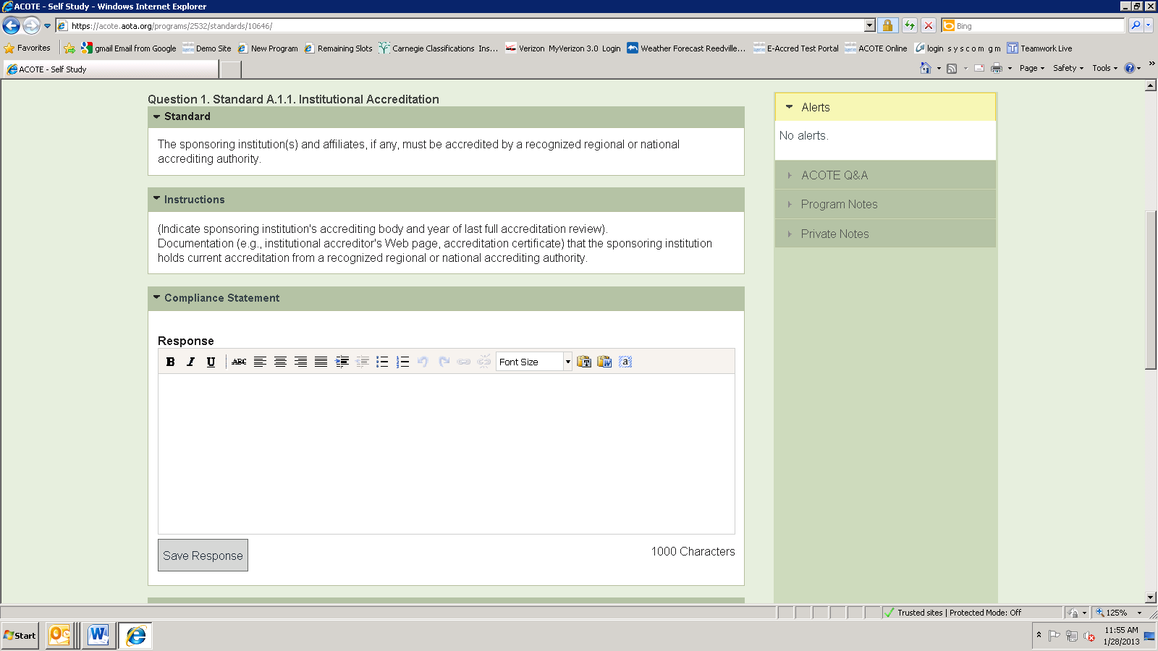

Under “Supporting Material”:
- Give your upload a title, (e.g., SACS Accreditation Certificate).
- Click “browse” to locate the file on your computer and enter.
- You may also enter a description if you wish.
- Click the “Upload Document” button.

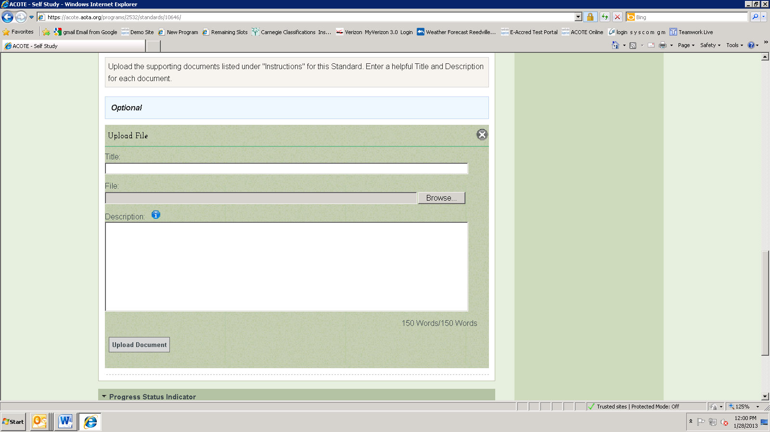

Under “Progress Status”, select the status you wish to set for that Standard. The designation is up to your institution. However, all Standards must be marked “Ready for Submission” before you will see a sign off box on the “HOME” tab to submit your report to your dean for signature.

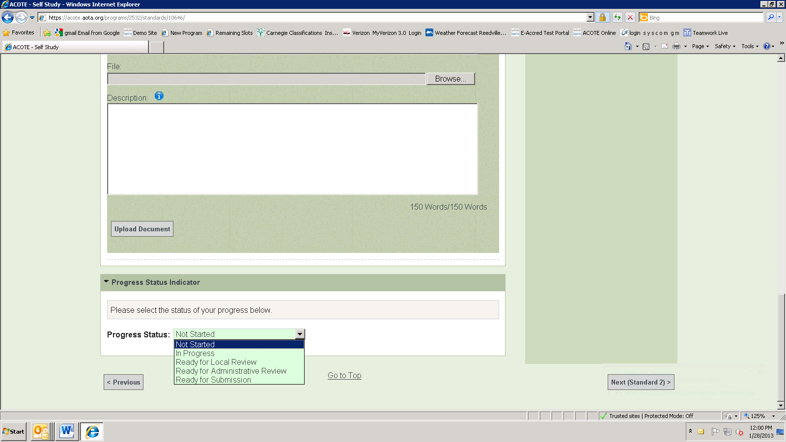

Click “Next Standard” to move to the next Standard.

