**INSTRUCTIONS FOR RESPONDING TO THE B CONTENT STANDARDS**

Log onto the ACOTE eAccreditation Portal (<https://acote.aota.org>) using a browser such as Firefox or Chrome. Follow the instructions below for all of the B content Standards included in the Interim Report or Self-Study Report:

* To be able to complete this section, the user must have the “Add Curriculum Data” button checked in the “Users” tab.
* Complete the Course Summary form in the “CURRICULUM” tab and upload the related syllabi that include course objectives, learning activities, and instructional methods and materials. (NOTE: Level II fieldwork syllabi may not be used to document compliance with a B Standard).
* In each Course Summary, link up to 3 courses that best exhibit coverage of each content Standard. A maximum of 3 courses can be linked to each Standard. Once linked, those courses will automatically populate the "Courses" section under each B Standard.
* In the "Compliance Statement" response box, summarize how the program meets each B Standard.
* In the “Supporting Material” section, upload example(s) used to document the assessment measure(s) used to meet this Standard (e.g., sample assignment, test question, project, etc.).

TO ADD COURSES:

1) Click on “CURRICULUM” tab in blue bar.

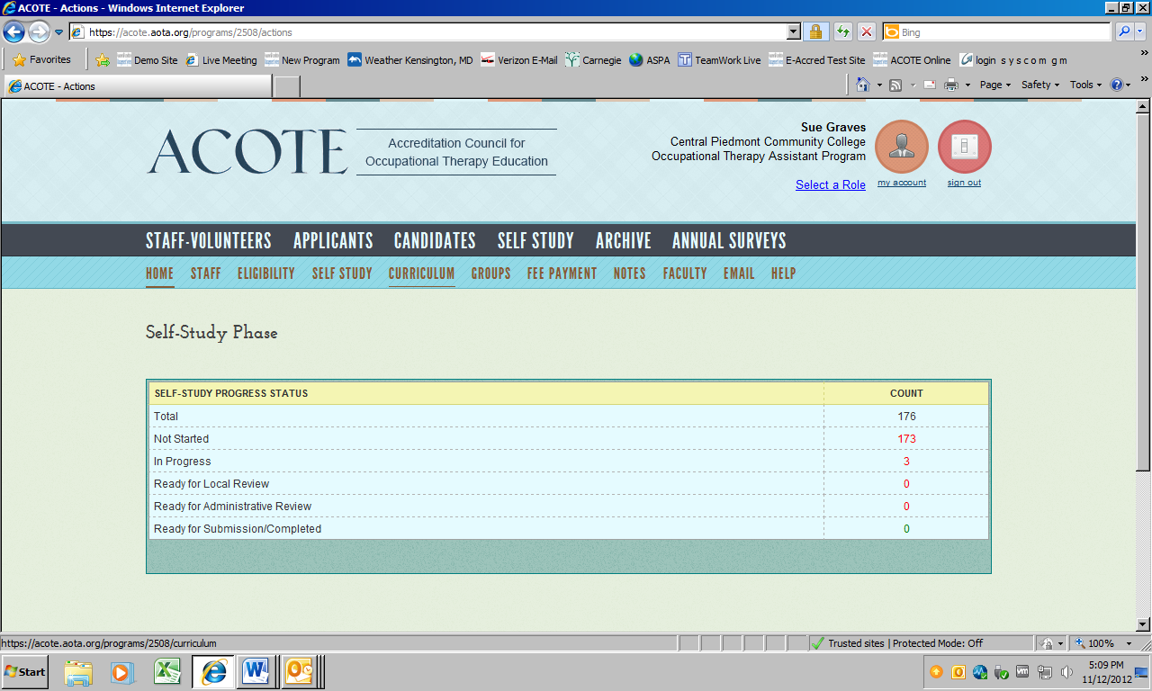

2) Click on “Add Course”.

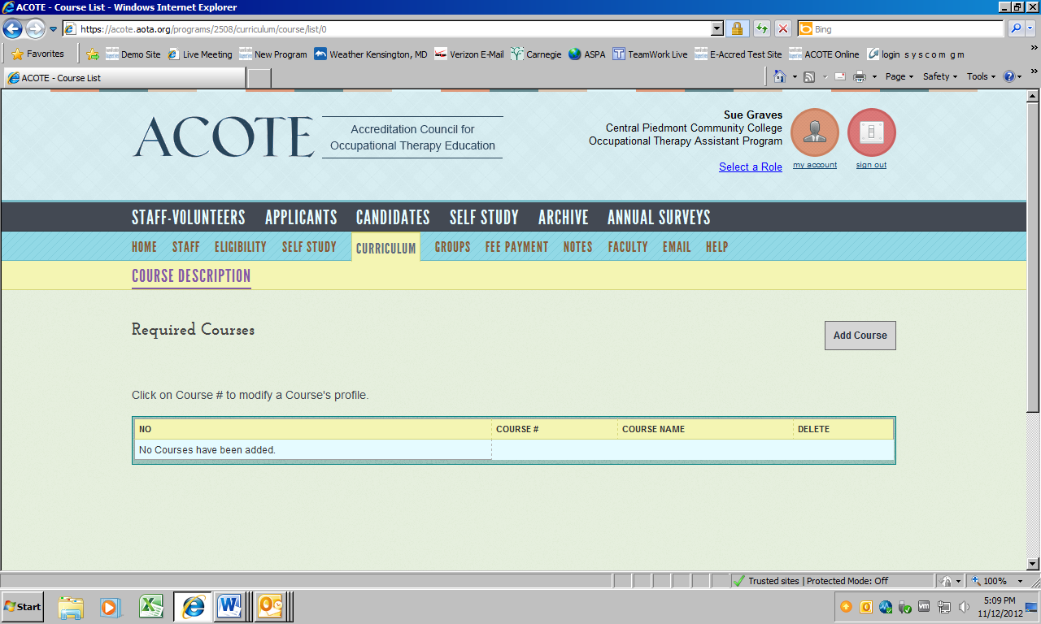

3) Complete Course Profile (Course Summary Sheet).

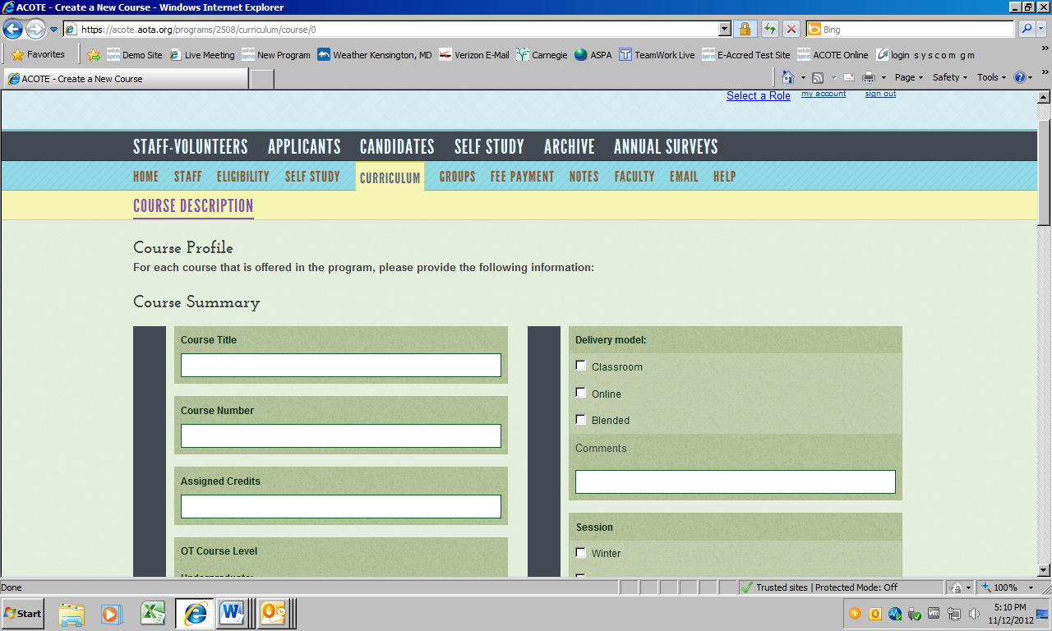

4) Click on “Upload File” to upload the course syllabi for that course.

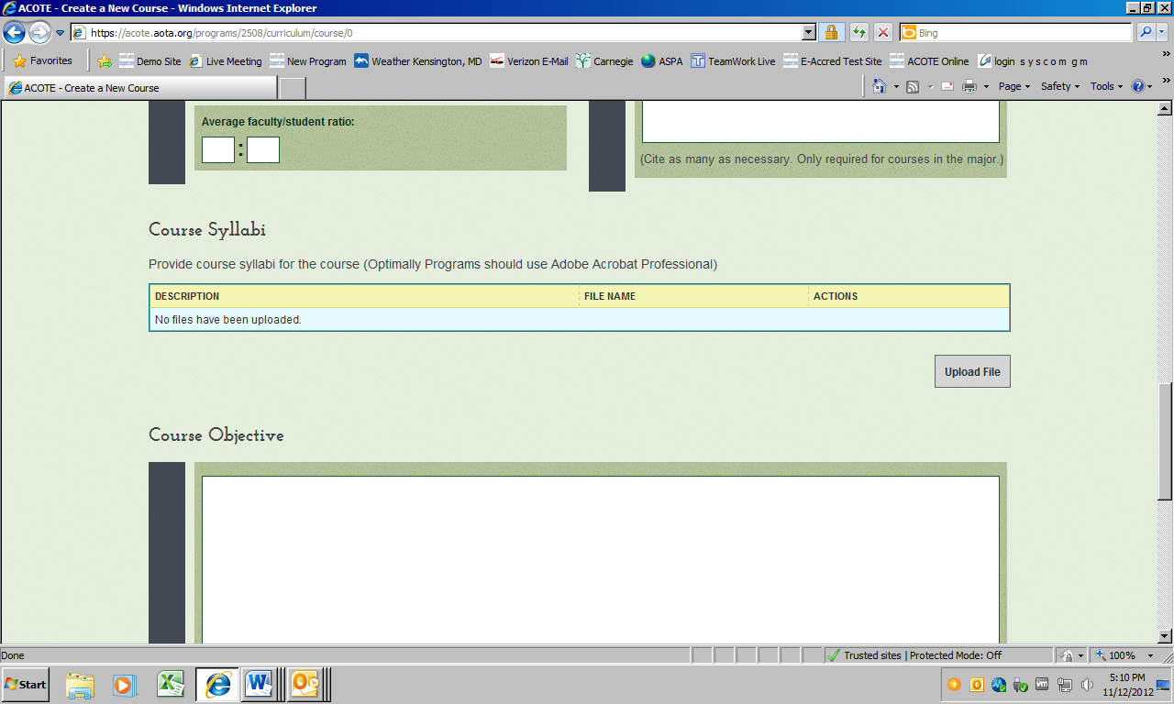

5) Add Course Objectives that relate to the Standard(s) you will be tying the course to. (IMPORTANT NOTE: This field is limited to 7,500 characters).

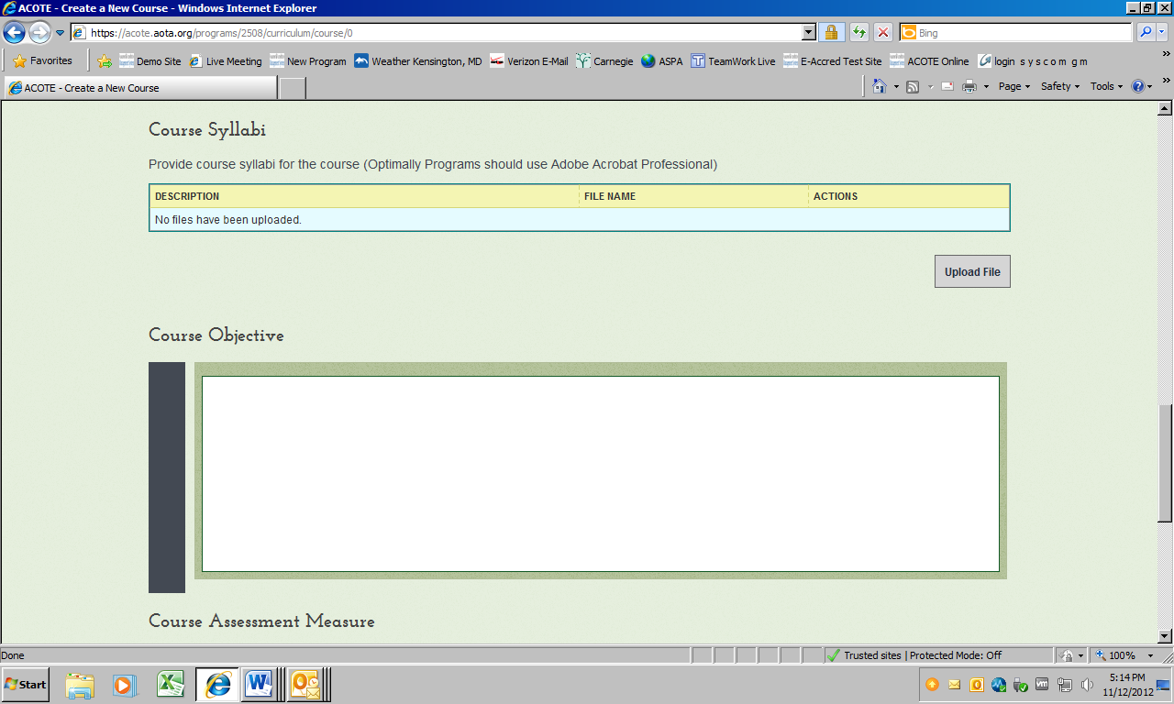

6) Select related Standards from “Course Standards Mapping” dropdown menu. Note that each Standard can have a maximum of 3 courses. Once the Standard has 3 courses, that Standard will no longer appear in the dropdown menu.

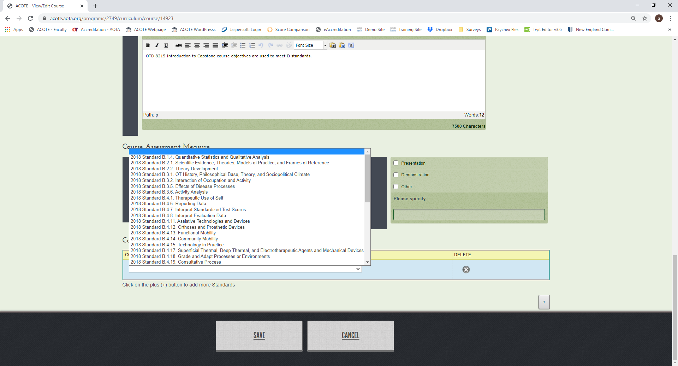

7) Click the **+** icon (lower right-hand side of screen) to add additional Standards.

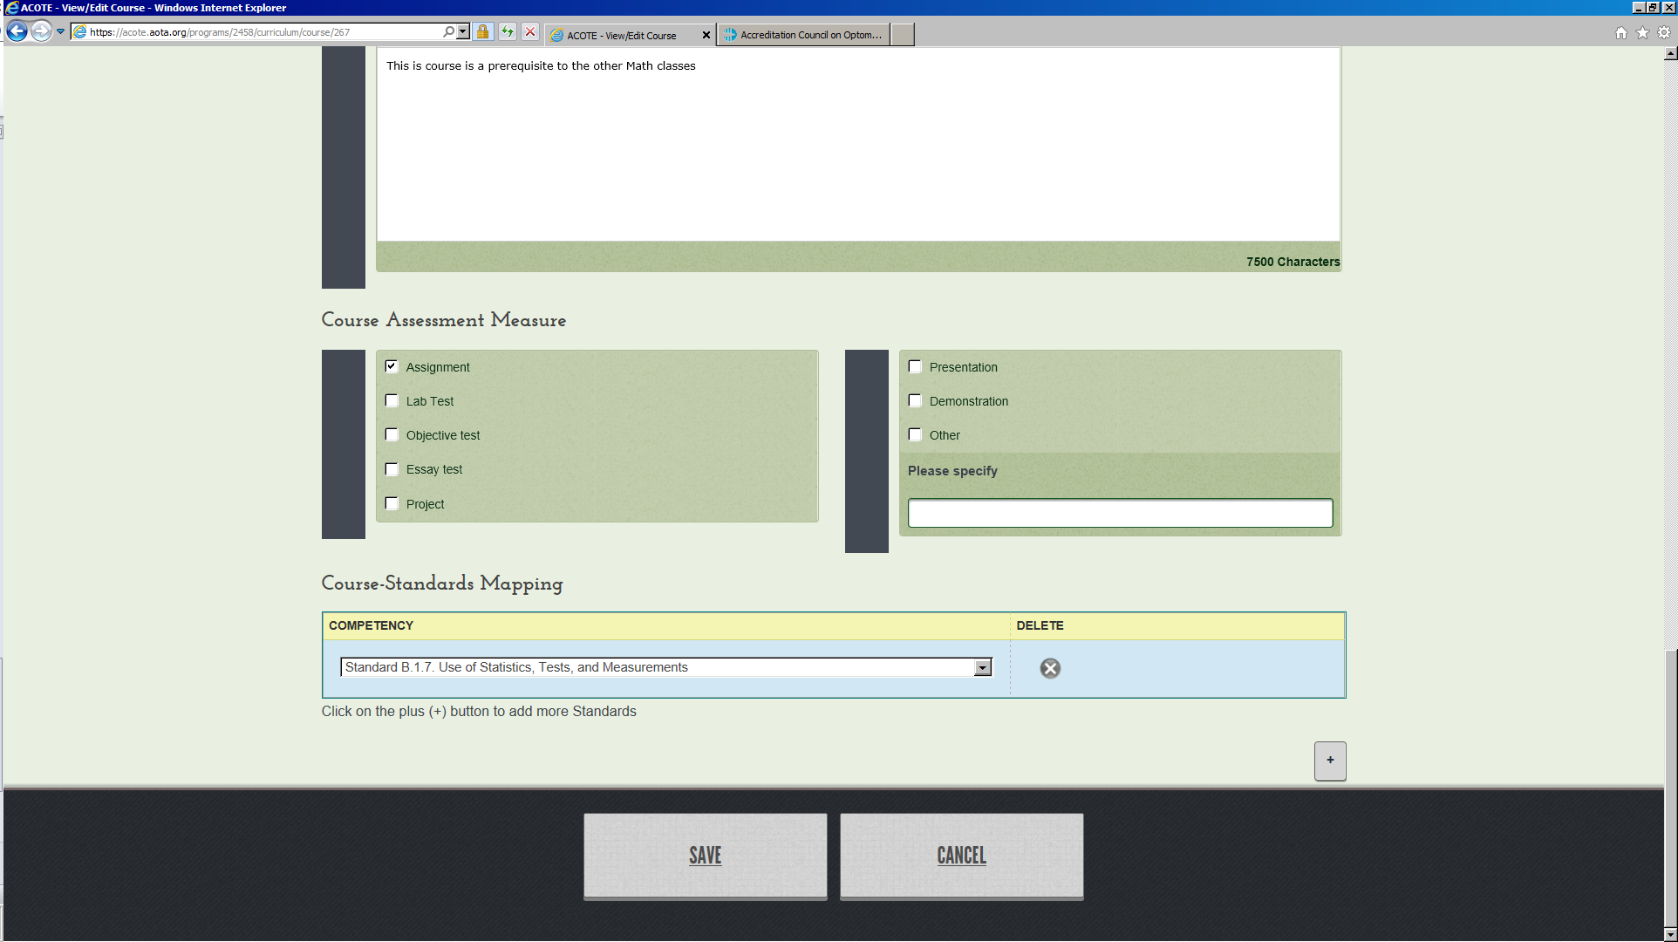

8) When you have completed the Course Summary Sheet, make sure to hit “SAVE” at the bottom of the page.

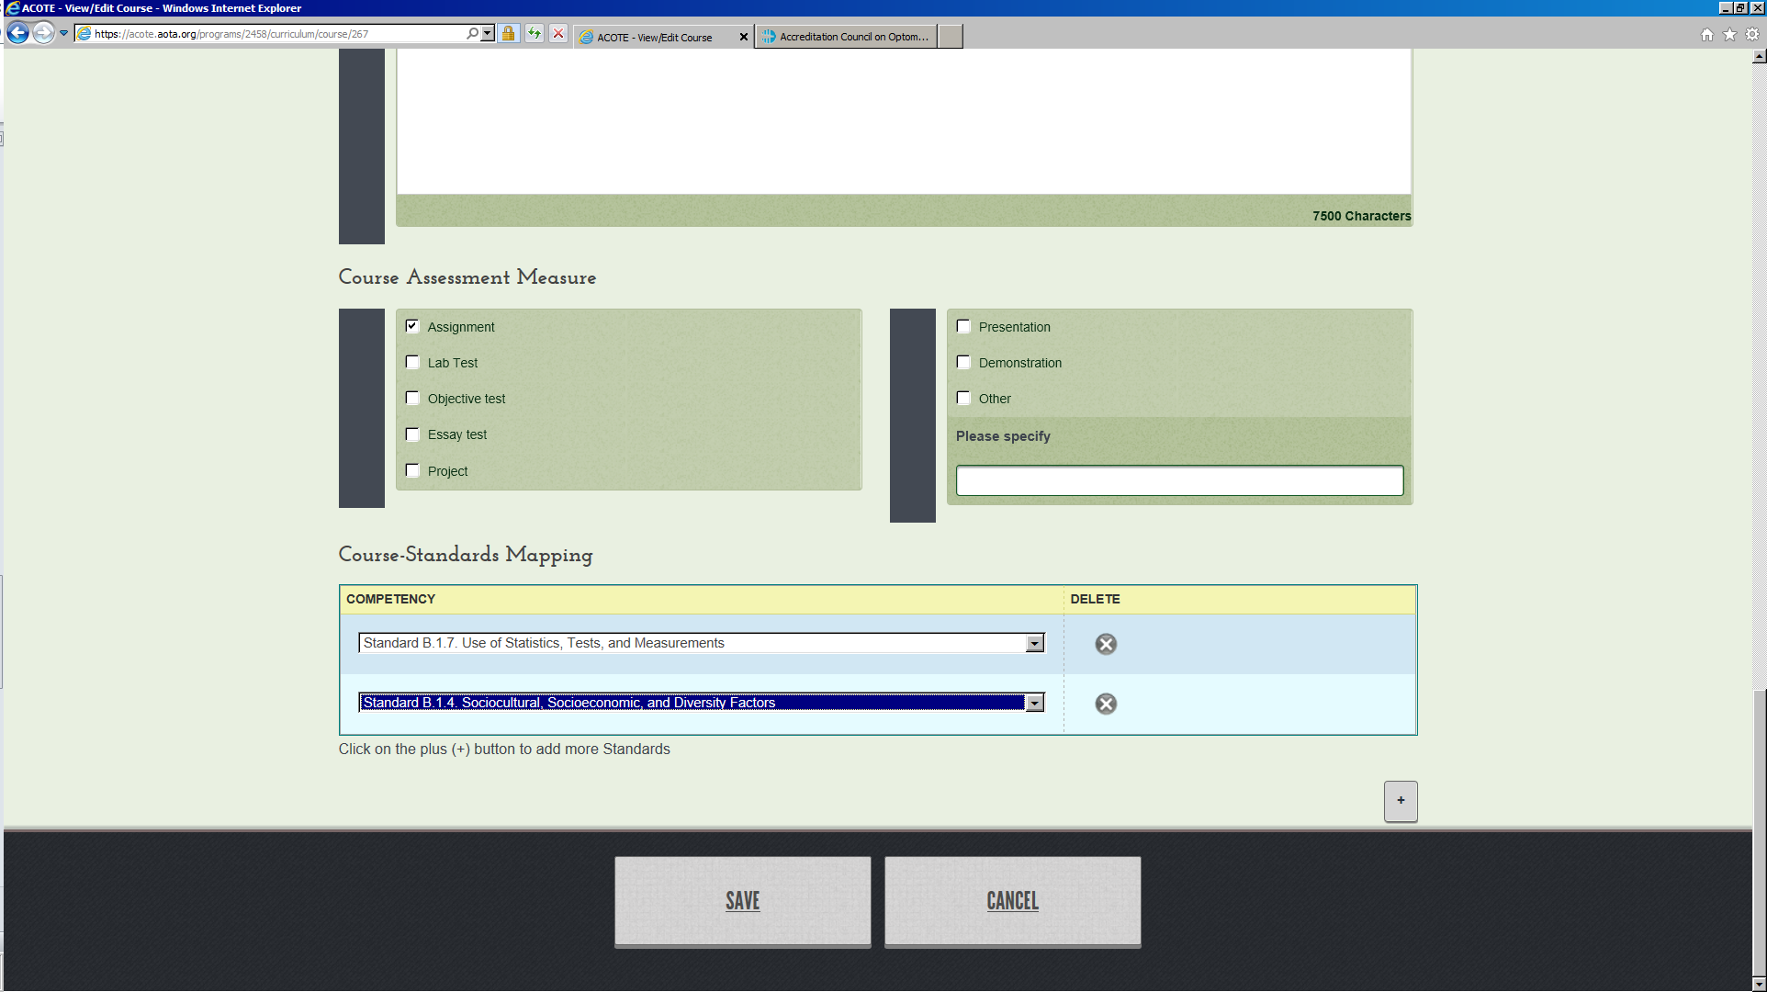

9) NOTE: When one or more Standards are selected, the course title and number will automatically populate the corresponding Standards in the Self-Study tab. If you wish to remove a course from a Standard the Self-Study tab, you must remove the link to that Standard from the Course Summary sheet in the Curriculum tab.

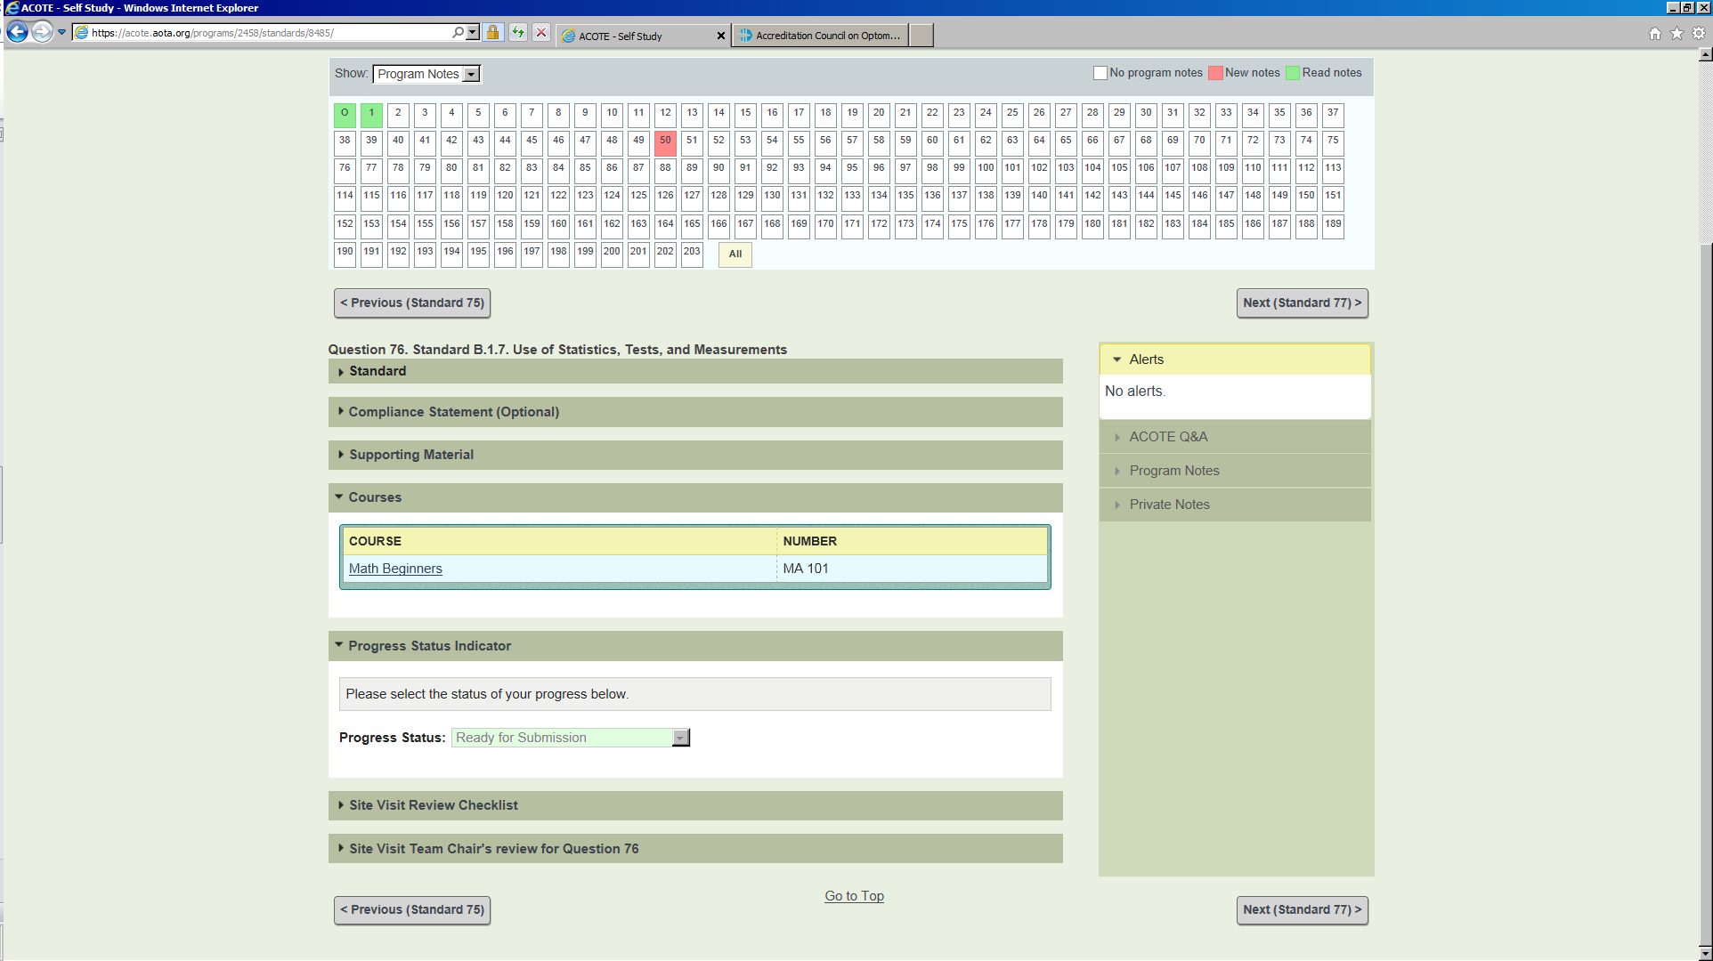

10) Once you have added courses, you may click on the “STANDARDS AND COURSE SUMMARY” tab under the “CURRICULUM” tab to view the courses you have linked to each Standard.

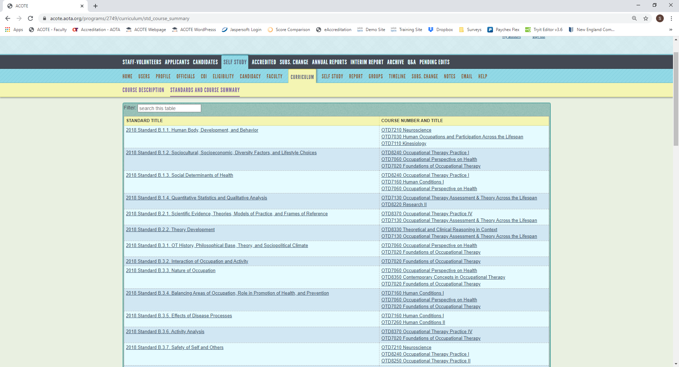

To edit saved Course Summary Sheets:

1) From the “Curriculum” tab, click on the Course Summary Sheet you wish to edit.

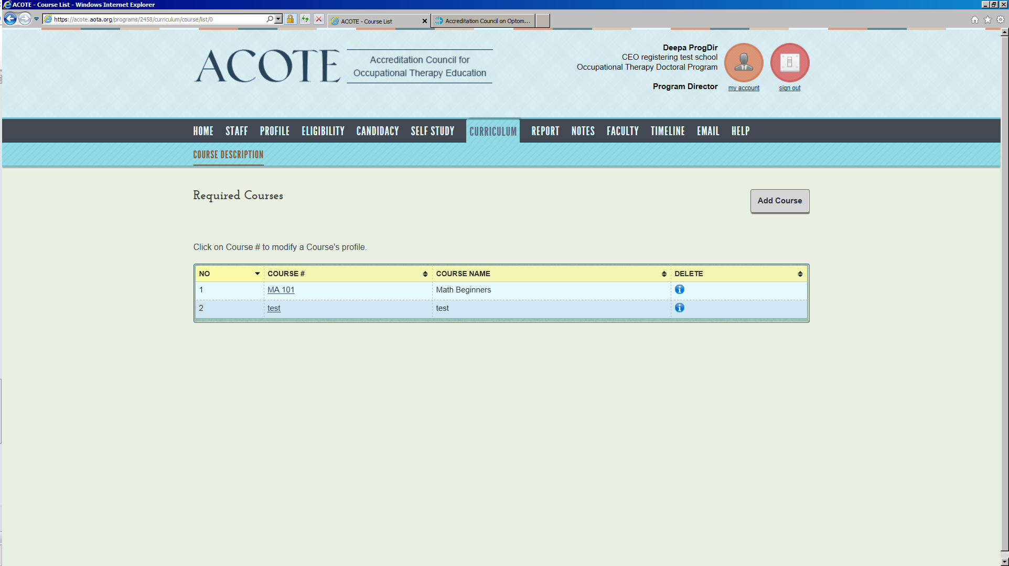

2) Click **Edit** button at the top of the Course Summary screen.

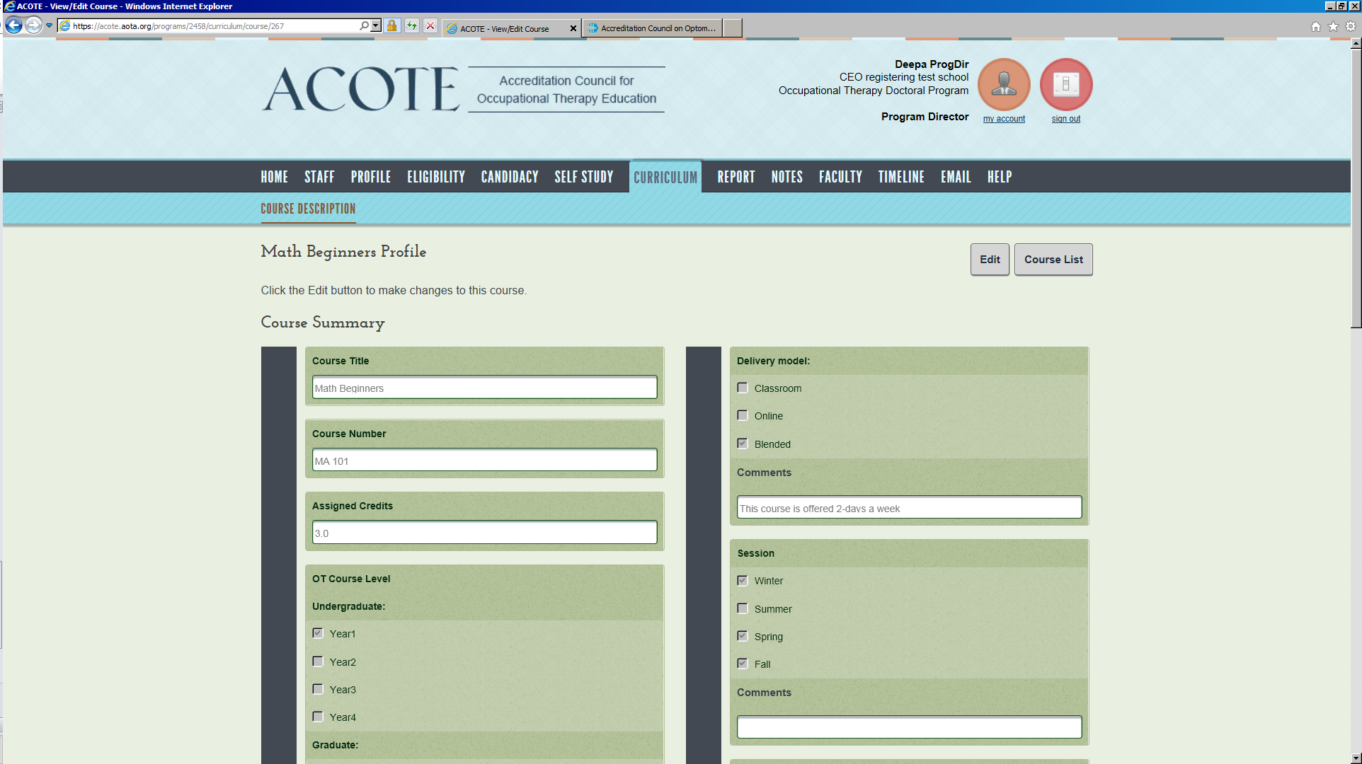

3) If you wish to delete a tie to a Standard for that course, scroll down to “Course-Standards Mapping” and click on the “X” in the delete column to remove that Standard link.

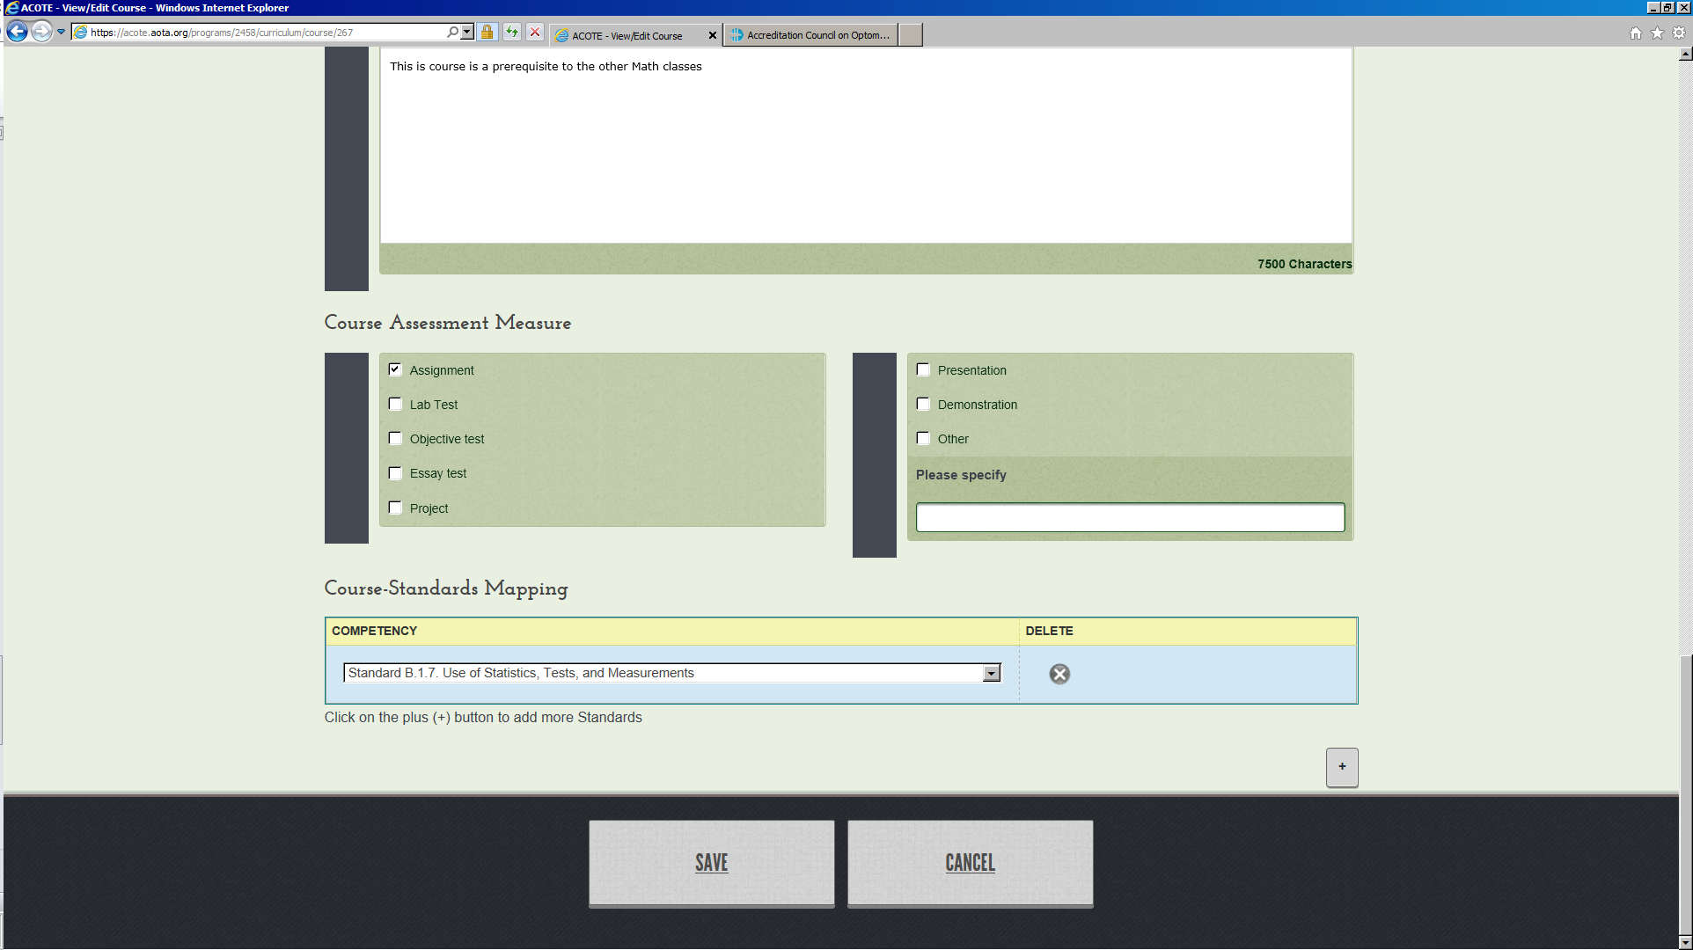

4) When all desired edits are complete, hit “SAVE” at the bottom.

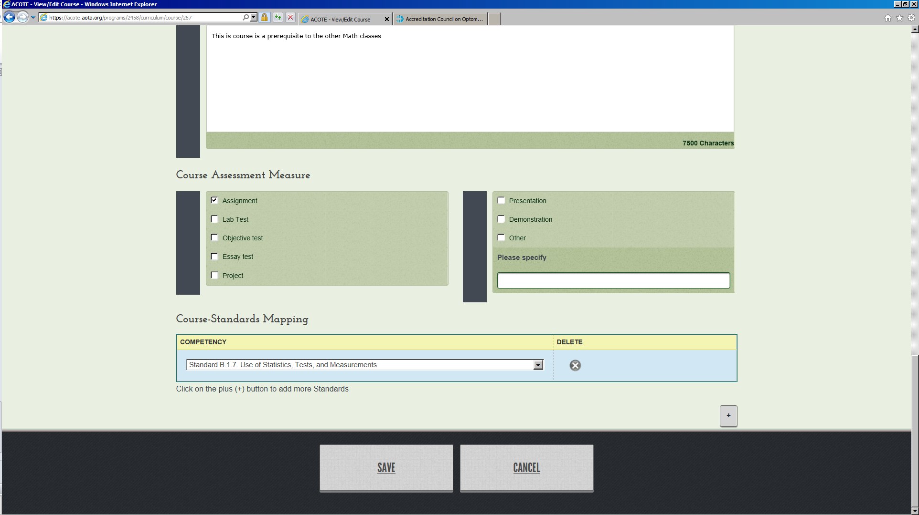

Questions? Contact [accred@aota.org](mailto:accred@aota.org)