**INSTRUCTIONS FOR SUBMITTING ASIGNIFICANT PROGRAM CHANGE**

1. Please review ACOTE Policy “IV.B.1. Additions or Changes” on the [ACOTE Policies and Procedures](https://acoteonline.org/accreditation-explained/policies/) webpage to appropriately categorize the program change and review the documentation to be submitted.
2. Log in (as program director) to ACOTE Online (<https://acote.aota.org>).
3. Click on “Subs. Change” in the black bar.

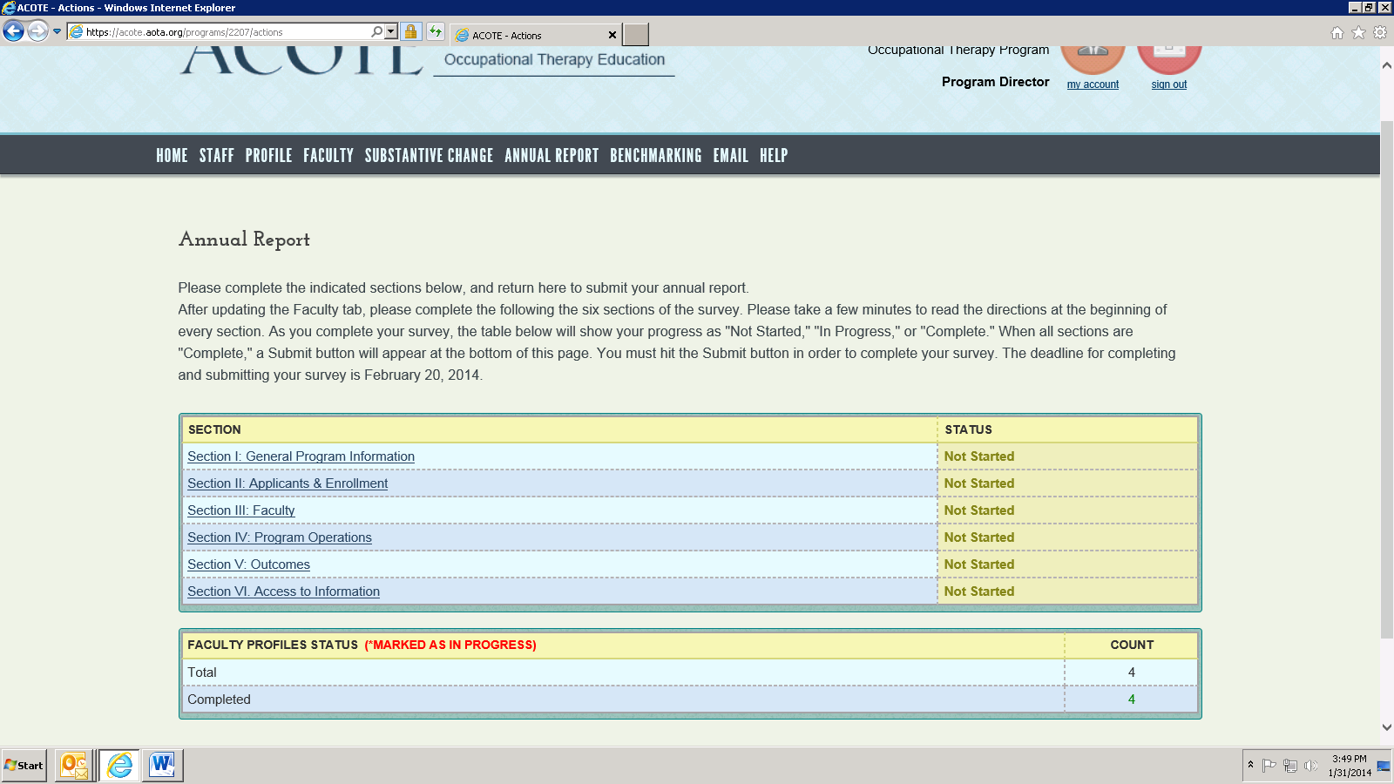

1. Click on “Add New Substantive Change” (blue bar).

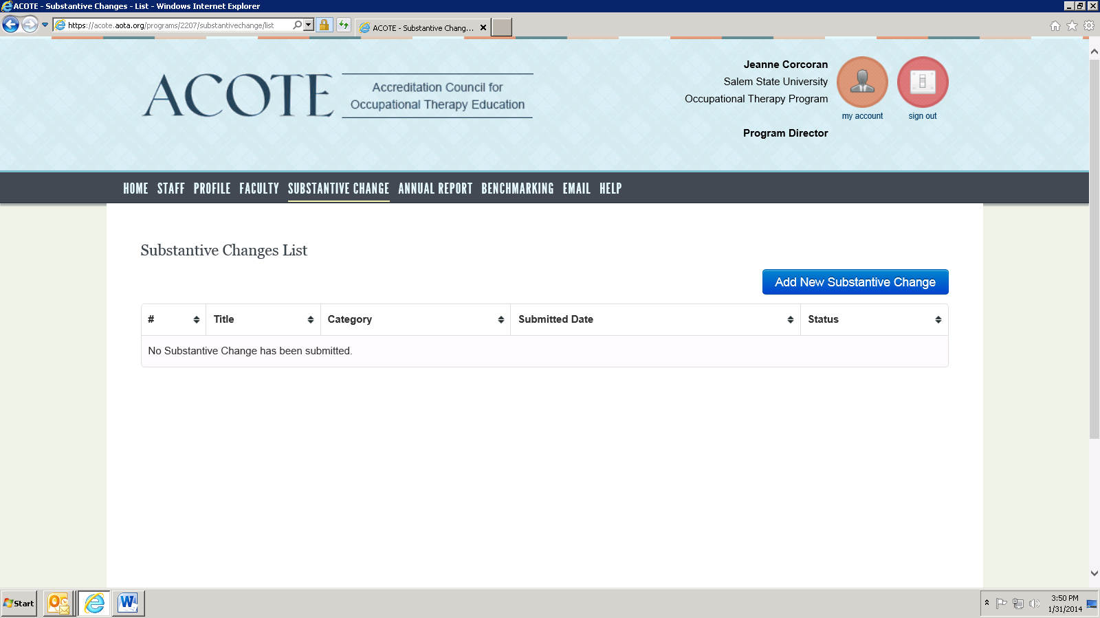

1. Select the radio button for a Significant Program Additions or Changes, Program Director Change or Other:

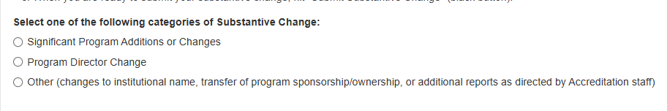

1. Add a title under “Substantive Change Title”, add a description in the “Description” box, and click on “Save Substantive Change” (blue bar).

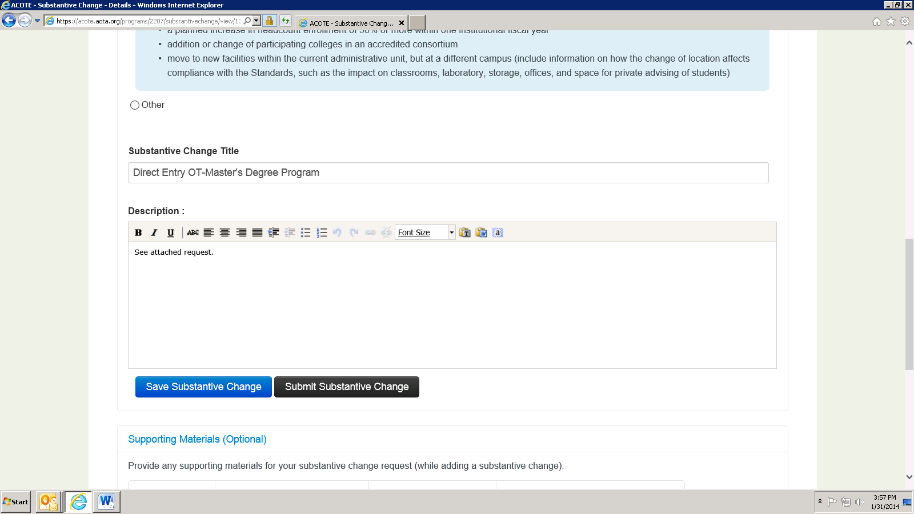

1. Under “Upload Documents”, add a title for your document to be uploaded, a description, and click on Browse.

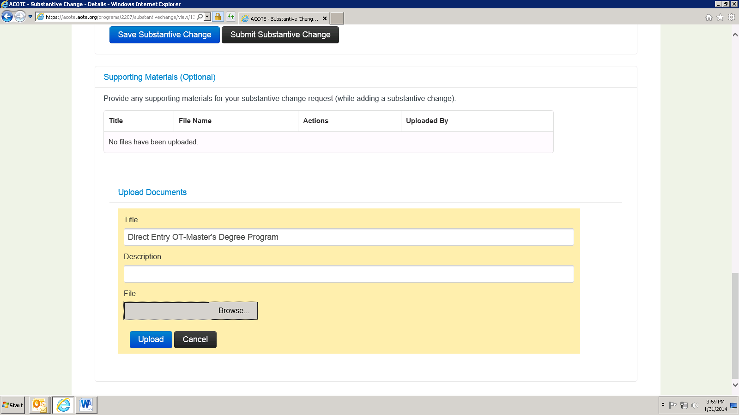

1. Once you have located the document you wish to upload, hit “Upload” (blue button).

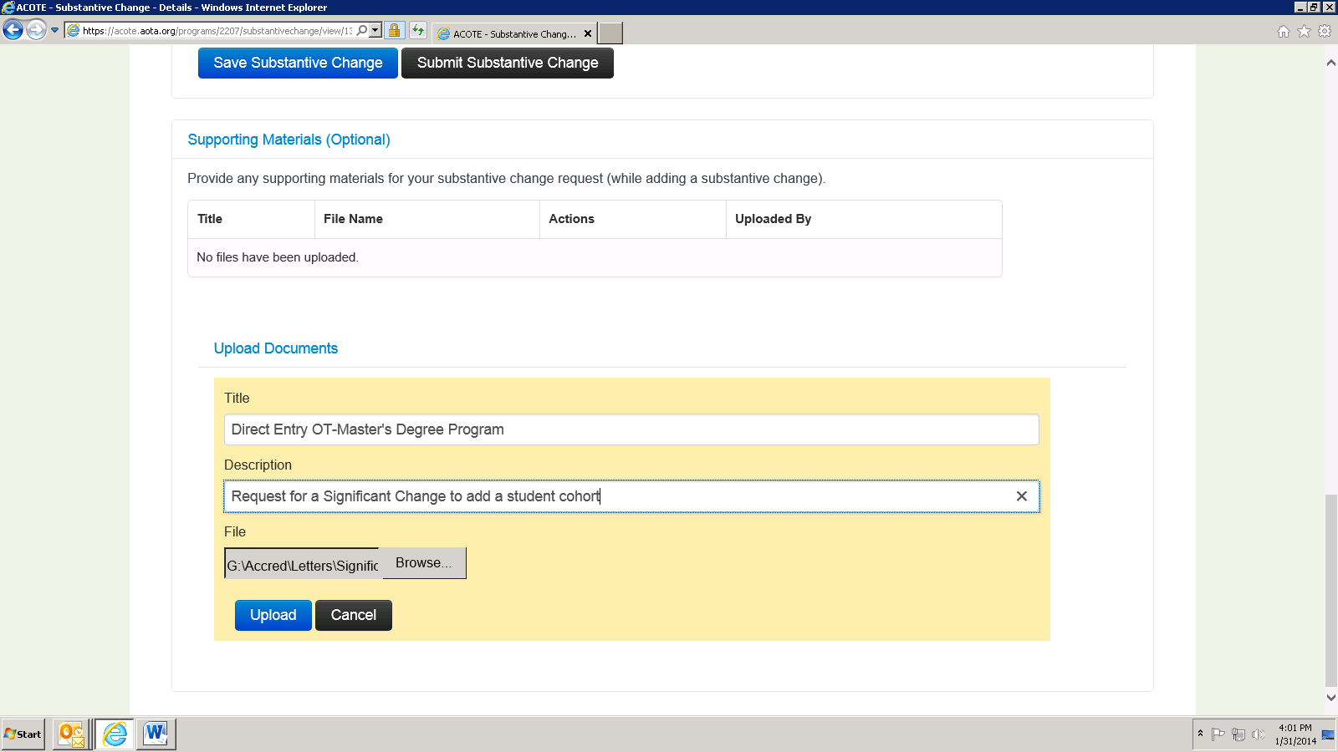

1. When you are ready to submit your substantive change, hit “Submit Substantive Change” (black button).

